**Table of Content**

1. **Dengue Fever**
   1. Origin
   2. Symptoms
2. **Causes**
3. **Treatment**
4. **Preventions**
5. **Infection Cycle of Dengue fever**
6. **Dengue Fever**

* Dengue (DENG-gey) fever is a mosquito-borne illness.
* It occurs in tropical and subtropical areas of the world.
* Mild dengue fever causes a high fever and flu-like symptoms.
* 1 in 4: About one in four people infected with dengue will get sick.
* For people who get sick with dengue, symptoms can be mild or severe.
* Severe dengue can be life-threatening within a few hours and often requires care at a hospital.
  1. **Origin**
* The [dengue](https://www.sciencedirect.com/topics/immunology-and-microbiology/dengue-fever) virus is a member of the [Flaviviridae](https://www.sciencedirect.com/topics/immunology-and-microbiology/flaviviridae) family.
* It is transmitted by [*Aedes aegypti*](https://www.sciencedirect.com/topics/immunology-and-microbiology/aedes-aegypti) mosquitoes.
* The first suspected outbreaks of dengue-like disease were reported in 1635 in Martinique and Guadeloupe and 1699 in Panama; however, reports of illnesses compatible with dengue fever occurred even earlier.
* The documentation of transmission of dengue by A. aegypti mosquitoes was done at the beginning of 19th century.
* Presently, this virus is responsible for causing more morbidity and mortality than any other [arbovirus](https://www.sciencedirect.com/topics/immunology-and-microbiology/arbovirus) illness in humans.
* This increase in incidence is attributed to the following four major factors

(1) Extraordinary growth of the global population;

(2) Deficiency of an effective mosquito control program in dengue-endemic areas; (3) increased travel by airplanes; and

(4) Deterioration of public health infrastructures in the underdeveloped countries over the last 30 years.

(Omar Saeed, 2020)

* 1. **Symptoms**
* Mild symptoms of dengue can be confused with other illnesses that cause fever, aches and pains, or a rash.

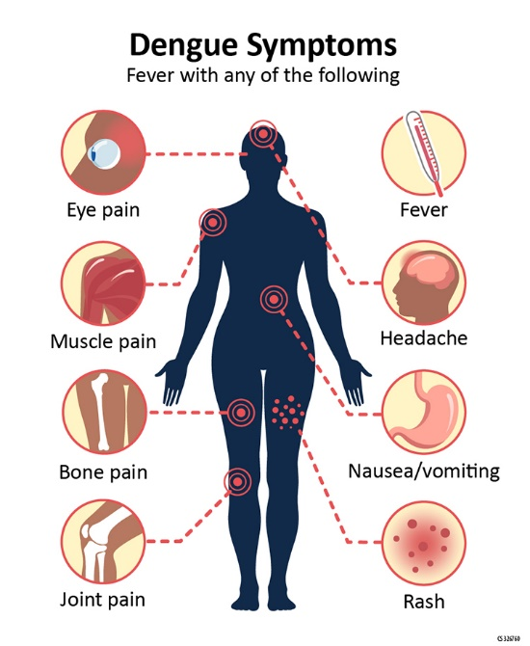

The most common symptom of dengue is **fever** with any of the following:

* Nausea, vomiting
* Rash
* Aches and pains (eye pain, typically behind the eyes, muscle, joint, or bone pain)
* Any warning sign.

1. **Causes**

Dengue fever is caused by any one of four types of dengue viruses. You can't get dengue fever from being around an infected person. Instead, dengue fever is spread through mosquito bites.

The two types of mosquitoes that most often spread the dengue viruses are common both in and around human lodgings. When a mosquito bites a person infected with a dengue virus, the virus enters the mosquito. Then, when the infected mosquito bites another person, the virus enters that person's bloodstream and causes an infection.

After you've recovered from dengue fever, you have long-term immunity to the type of virus that infected you — but not to the other three dengue fever virus types. This means you can be infected again in the future by one of the other three virus types. Your risk of developing severe dengue fever increases if you get dengue fever a second, third or fourth time.

Risk factors

You have a greater risk of developing dengue fever or a more severe form of the disease if:

* **You live or travel in tropical areas.** Being in tropical and subtropical areas increases your risk of exposure to the virus that causes dengue fever. Especially high-risk areas include Southeast Asia, the western Pacific islands, Latin America and Africa.
* **You have had dengue fever in the past.** Previous infection with a dengue fever virus increases your risk of severe symptoms if you get dengue fever again.

1. **Treatment**

* There is no specific medicine to treat dengue.
* Treat the symptoms of dengue and see your healthcare provider.
* While recovering from dengue fever, drink plenty of fluids. Call your doctor right away.
* If you think you may have dengue fever, you should use pain relievers with acetaminophen and avoid medicines with aspirin, which could worsen bleeding.
* You should also rest, drink plenty of fluids, and see your doctor. If you start to feel worse in the first 24 hours after your fever goes down.
* You should get to a hospital immediately to be checked for complications.

1. **Precautions**

The best way to prevent the disease is to prevent bites by infected mosquitoes, particularly if you are living in or traveling to a tropical area. This involves protecting yourself and making efforts to keep the mosquito population down. In 2019, the FDA approved a vaccine called Dengvaxia to help prevent the disease from occurring in adolescents aged 9 to 16 who have already been infected by dengue. But, there currently is no vaccine to prevent the general population from contracting it.

To protect yourself:

* Use mosquito repellents, even indoors.
* When outdoors, wear long-sleeved shirts and long pants tucked into socks.
* When indoors, use air conditioning if available.
* Make sure window and door screens are secure and free of holes. If sleeping areas are not screened or air conditioned, use mosquito nets.

1. **Infection Cycle of Dengue fever**

